Arabic Text:
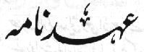
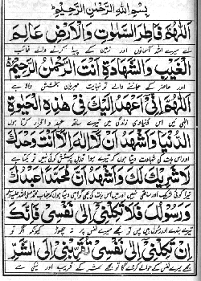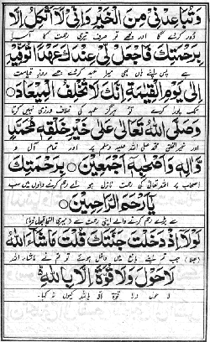
Note: If you are not able to read above arabic text, just click on the images they will open as bigger images.
reference: www.ummah.net
You can read it in Arabic with Urdu translation from following sources:
- Urdu Pages
- Here
English Text:
Bismilla Hirrahma Nirraheem
Allahumma Faatiras Samaawaati Wal Ardhi Aalimalghaybi Wash shahaadati Antar Rahmaanur Raheem.
Allahumma Inni Aahadu Ilayka Fihaazihil Hayaatiddunyaa Wa Ash Hadu Allaailaaha Illa Anta Wahdaka Laasharika Laka Wa Ash Hadu Anna Muhammadan Abduka Wa Rasuluka
Falaa Takilni Ilaa Nafsi FaInnaka Intakilni Ilaa Nafsi Tuqarribni Ilash Sharri Watubaa Idnee Minal Khayri Wa Inni Laa Attakilo
Illa Birahmatika Faj Alli Indaka Ahadan Tuwaffihi Ilaa Yawmil Qiyaamati Innaka Laa Tukhlifulmiyaad.
Wa Sallallaahu Ta’alaa Alaa Khayri Khalqihi Muhammadinw Wa Aalihi Wa As-haabihi Aajmain.
Birahmatika Yaa Arhamar Raahimeen.
Lawlaa Izdakhalta Jannataka Qulta Maashaaa Allahu Laahawla Walaa Quwwata Illa Billah.

Source: yanabi.com
Translation of ‘Ahd Namah
(Promise to Allah)
In the Name of Allah, The Beneficent, The Merciful
O Allah! The Creator of the skies and the earth
The Knower of the hidden and the open
Your are The Beneficent, The Merciful
O Allah! I promise you in this earthly life
and I bear witness that
that there is no one worthy of worship except You
You are One and Only without any partner
and I bear witness that
Sayyidina Hazrat Muhammad Sallallahu alaihi wa Sallam
is Your servant and Your Messenger
(O Allah!) Please do not leave me to my own self
Because if You abandon me to my own desires
I might be drawn towards evil and away from goodness
and I have no support except Your Mercy
So accept my promise with You
to be kept till the Day of Judgement
Truly, You never break a promise
And may the blessings of Allah, The Exalted
be on his best creation
Sayyidina Hazrat Muhammad Sallallahu alaihi wa Sallam
and on his family and all companions
(O Allah! Accept this prayer)
With Your Mercy, O The Most Merciful of those who show mercy.
FROM: http://gulamemustafa.wordpress.com/2009/10/19/ahad-nama-arabic-text-english-text-with-translation-in-urdu-and-english/

